Django DBMS Project Report

Software Engineering Team Project

Team members:

Chao Chen, Saheed Adepoju, Yihang Zhao

Fall 2016

Content

1. Project Commitment 3
2. User Stories 4

2.1 Use case card 4

2.2 Activity Diagram 8

2.3 Swimlane Diagram 9

1. Working Code 10

3.1 Data Model Sample 10

3.2 Interface 11

Below figure shows the overview of the web application’s framework, it also demonstrate how the web view handler interact with the user view an data models. 11

3.3 Code Sample 12

3.4 User Interface Screen 13

1. Project Repository and Tools 14

4.1 Repository 14

4.2 SCRUM Tool 15

1. Weekly SCRUM Sheets 16

# Project Commitment

The target of Django DBMS project is to develop a web-based platform for small store owner or manager to manage resources and for the staffs to conduct their regular works.

This project is built on top of Django-based web service, therefore it only need to be deployed on specified server instead of to be deployed on different working environment. All the user need are just the internet and web browser.

Below figure shows the project commitment form:

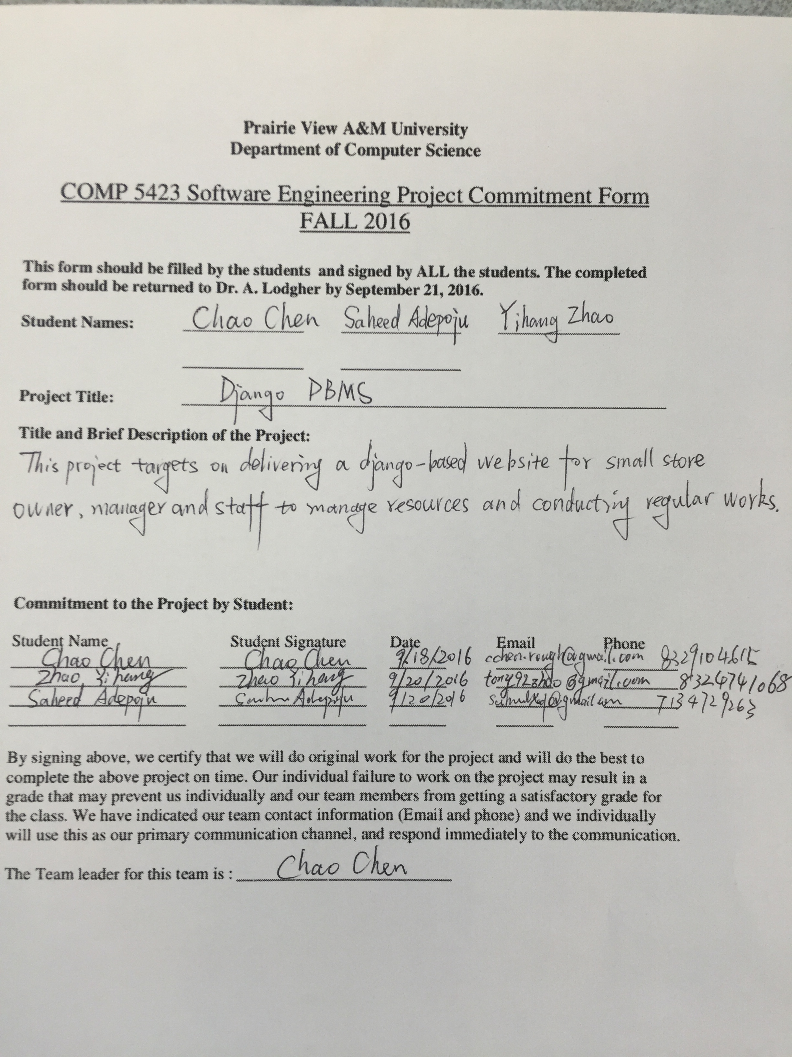

# User Stories

2.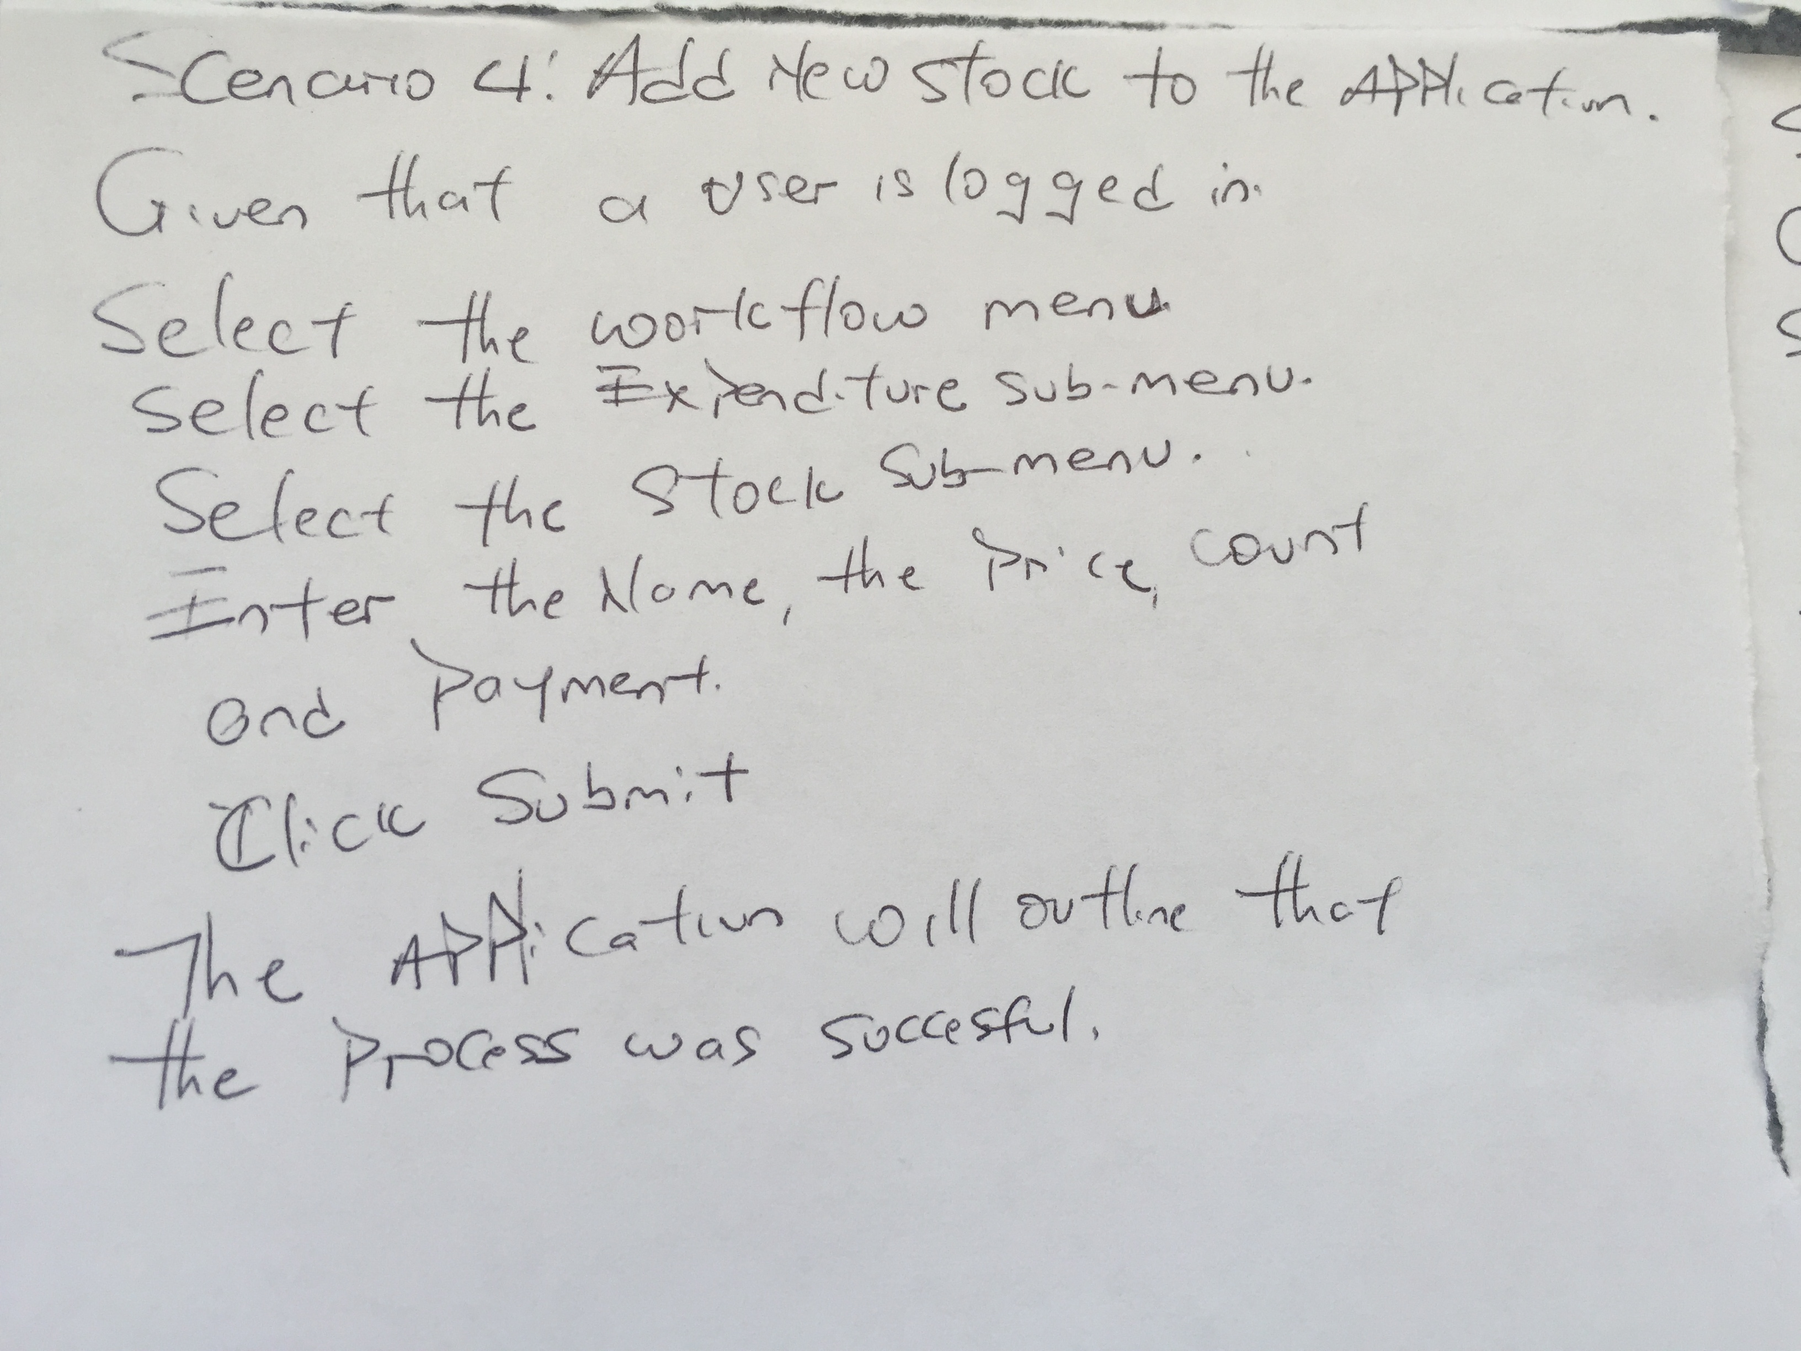1 Use case card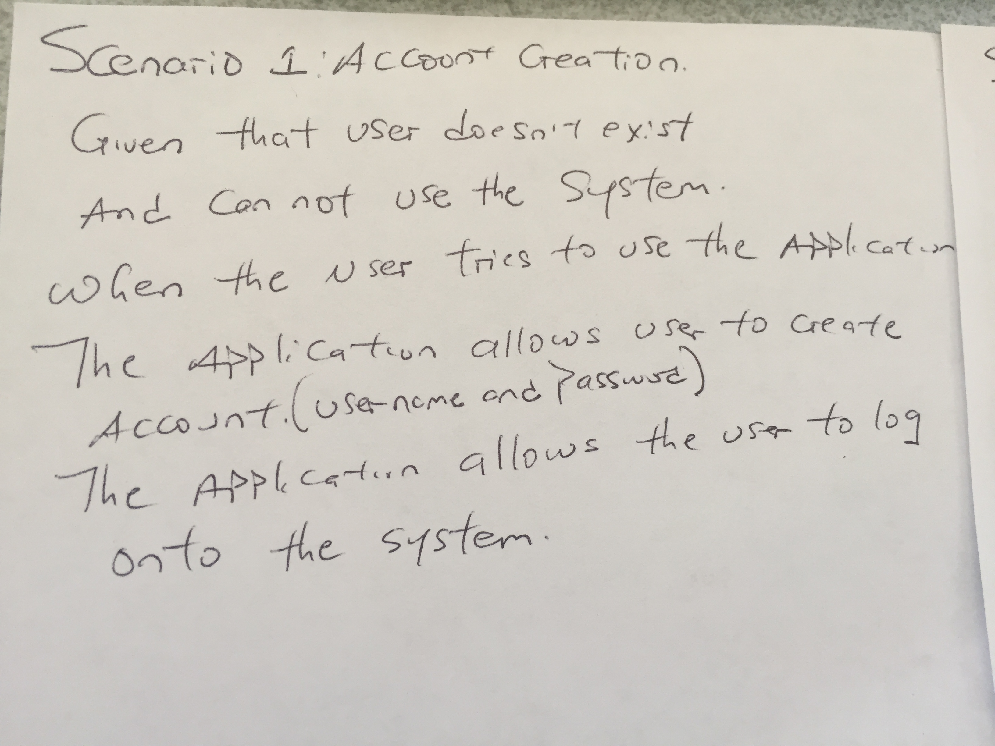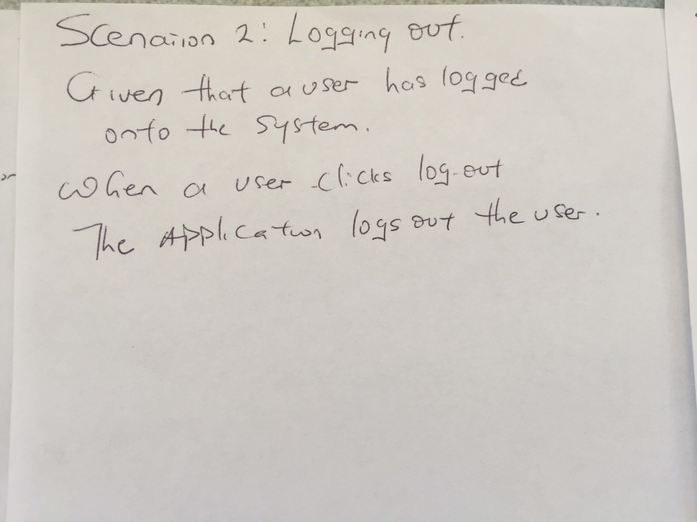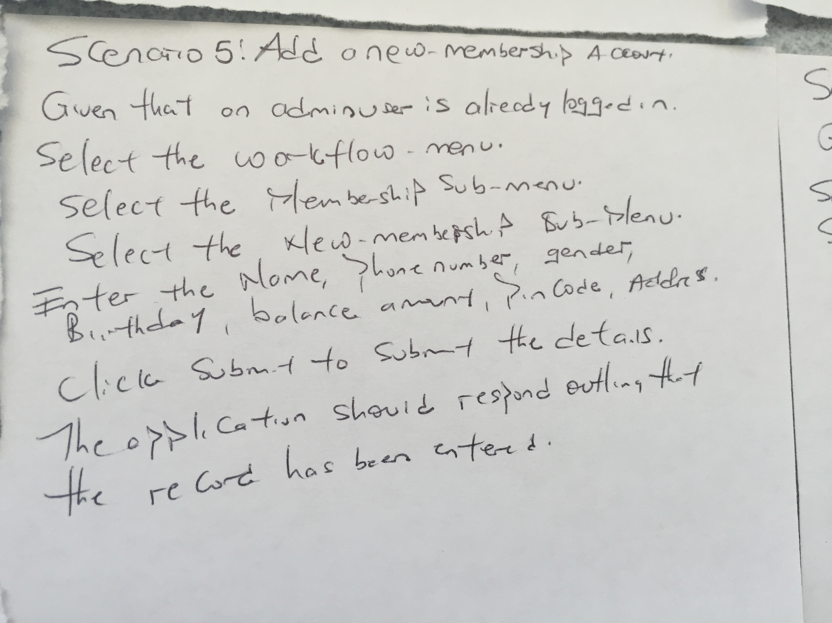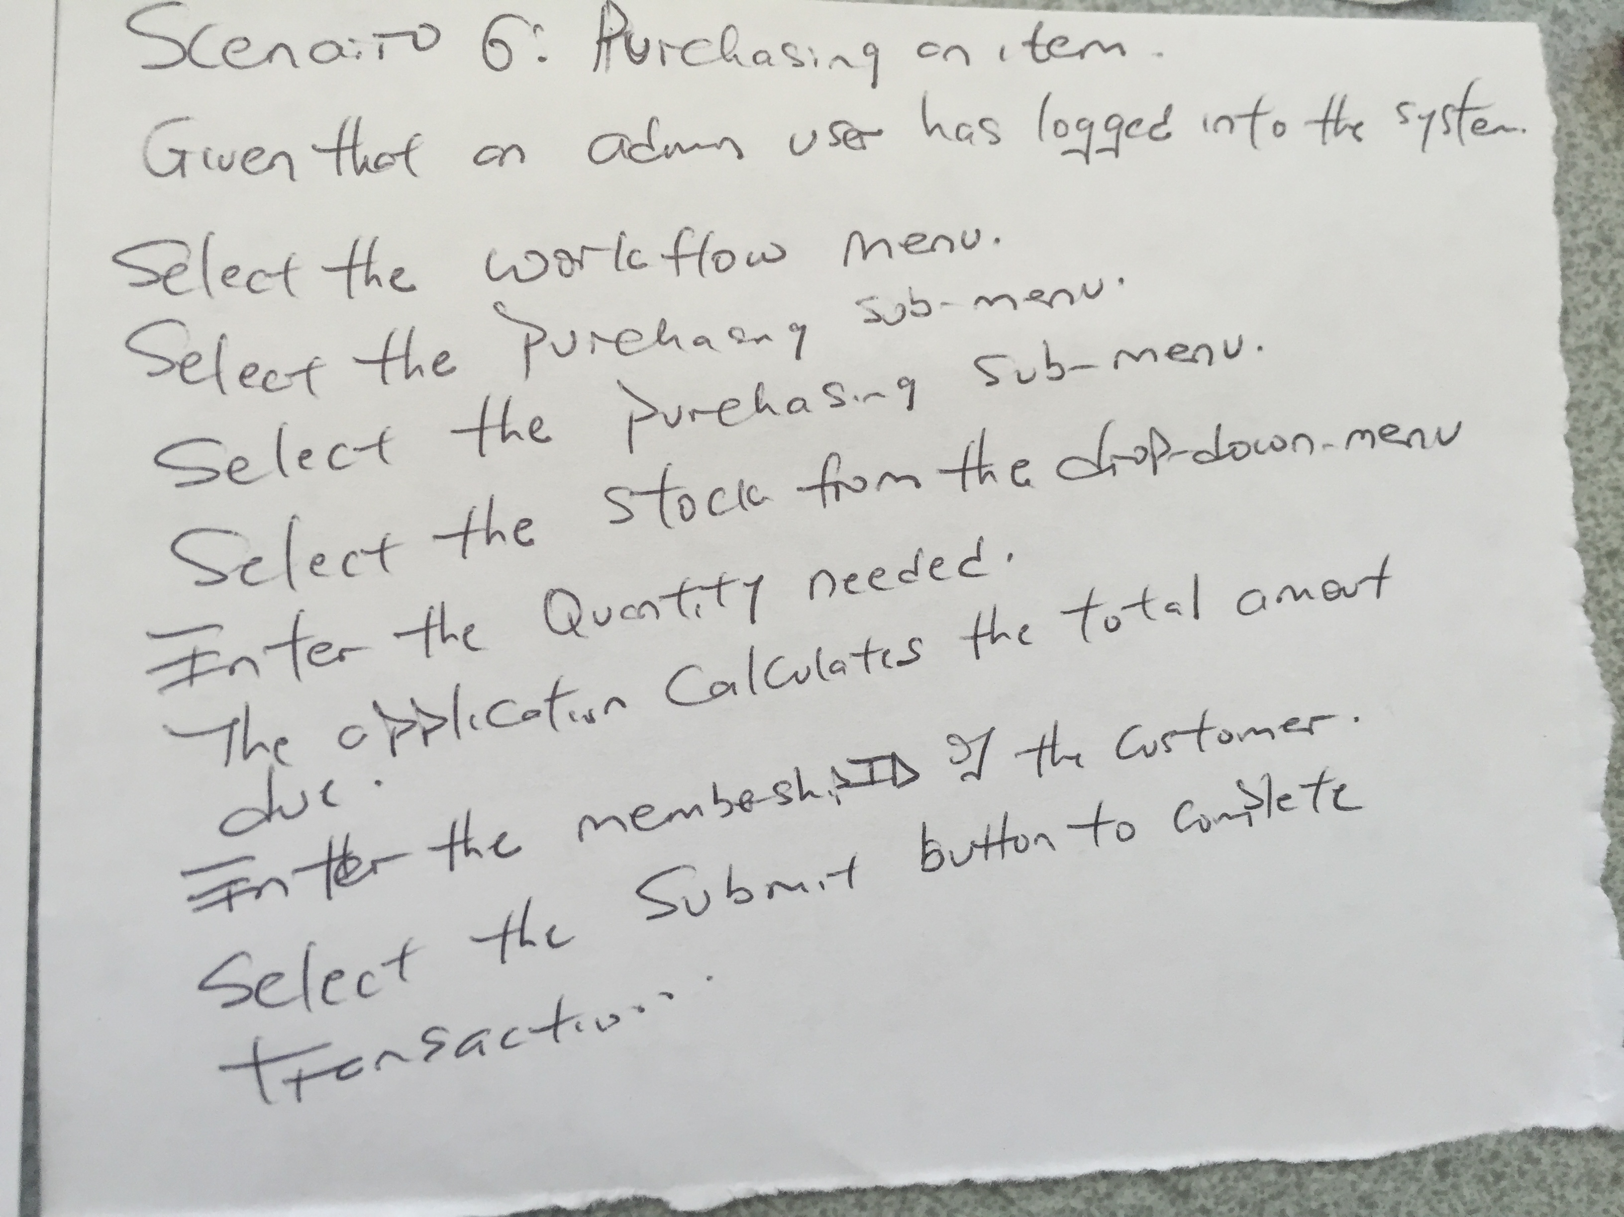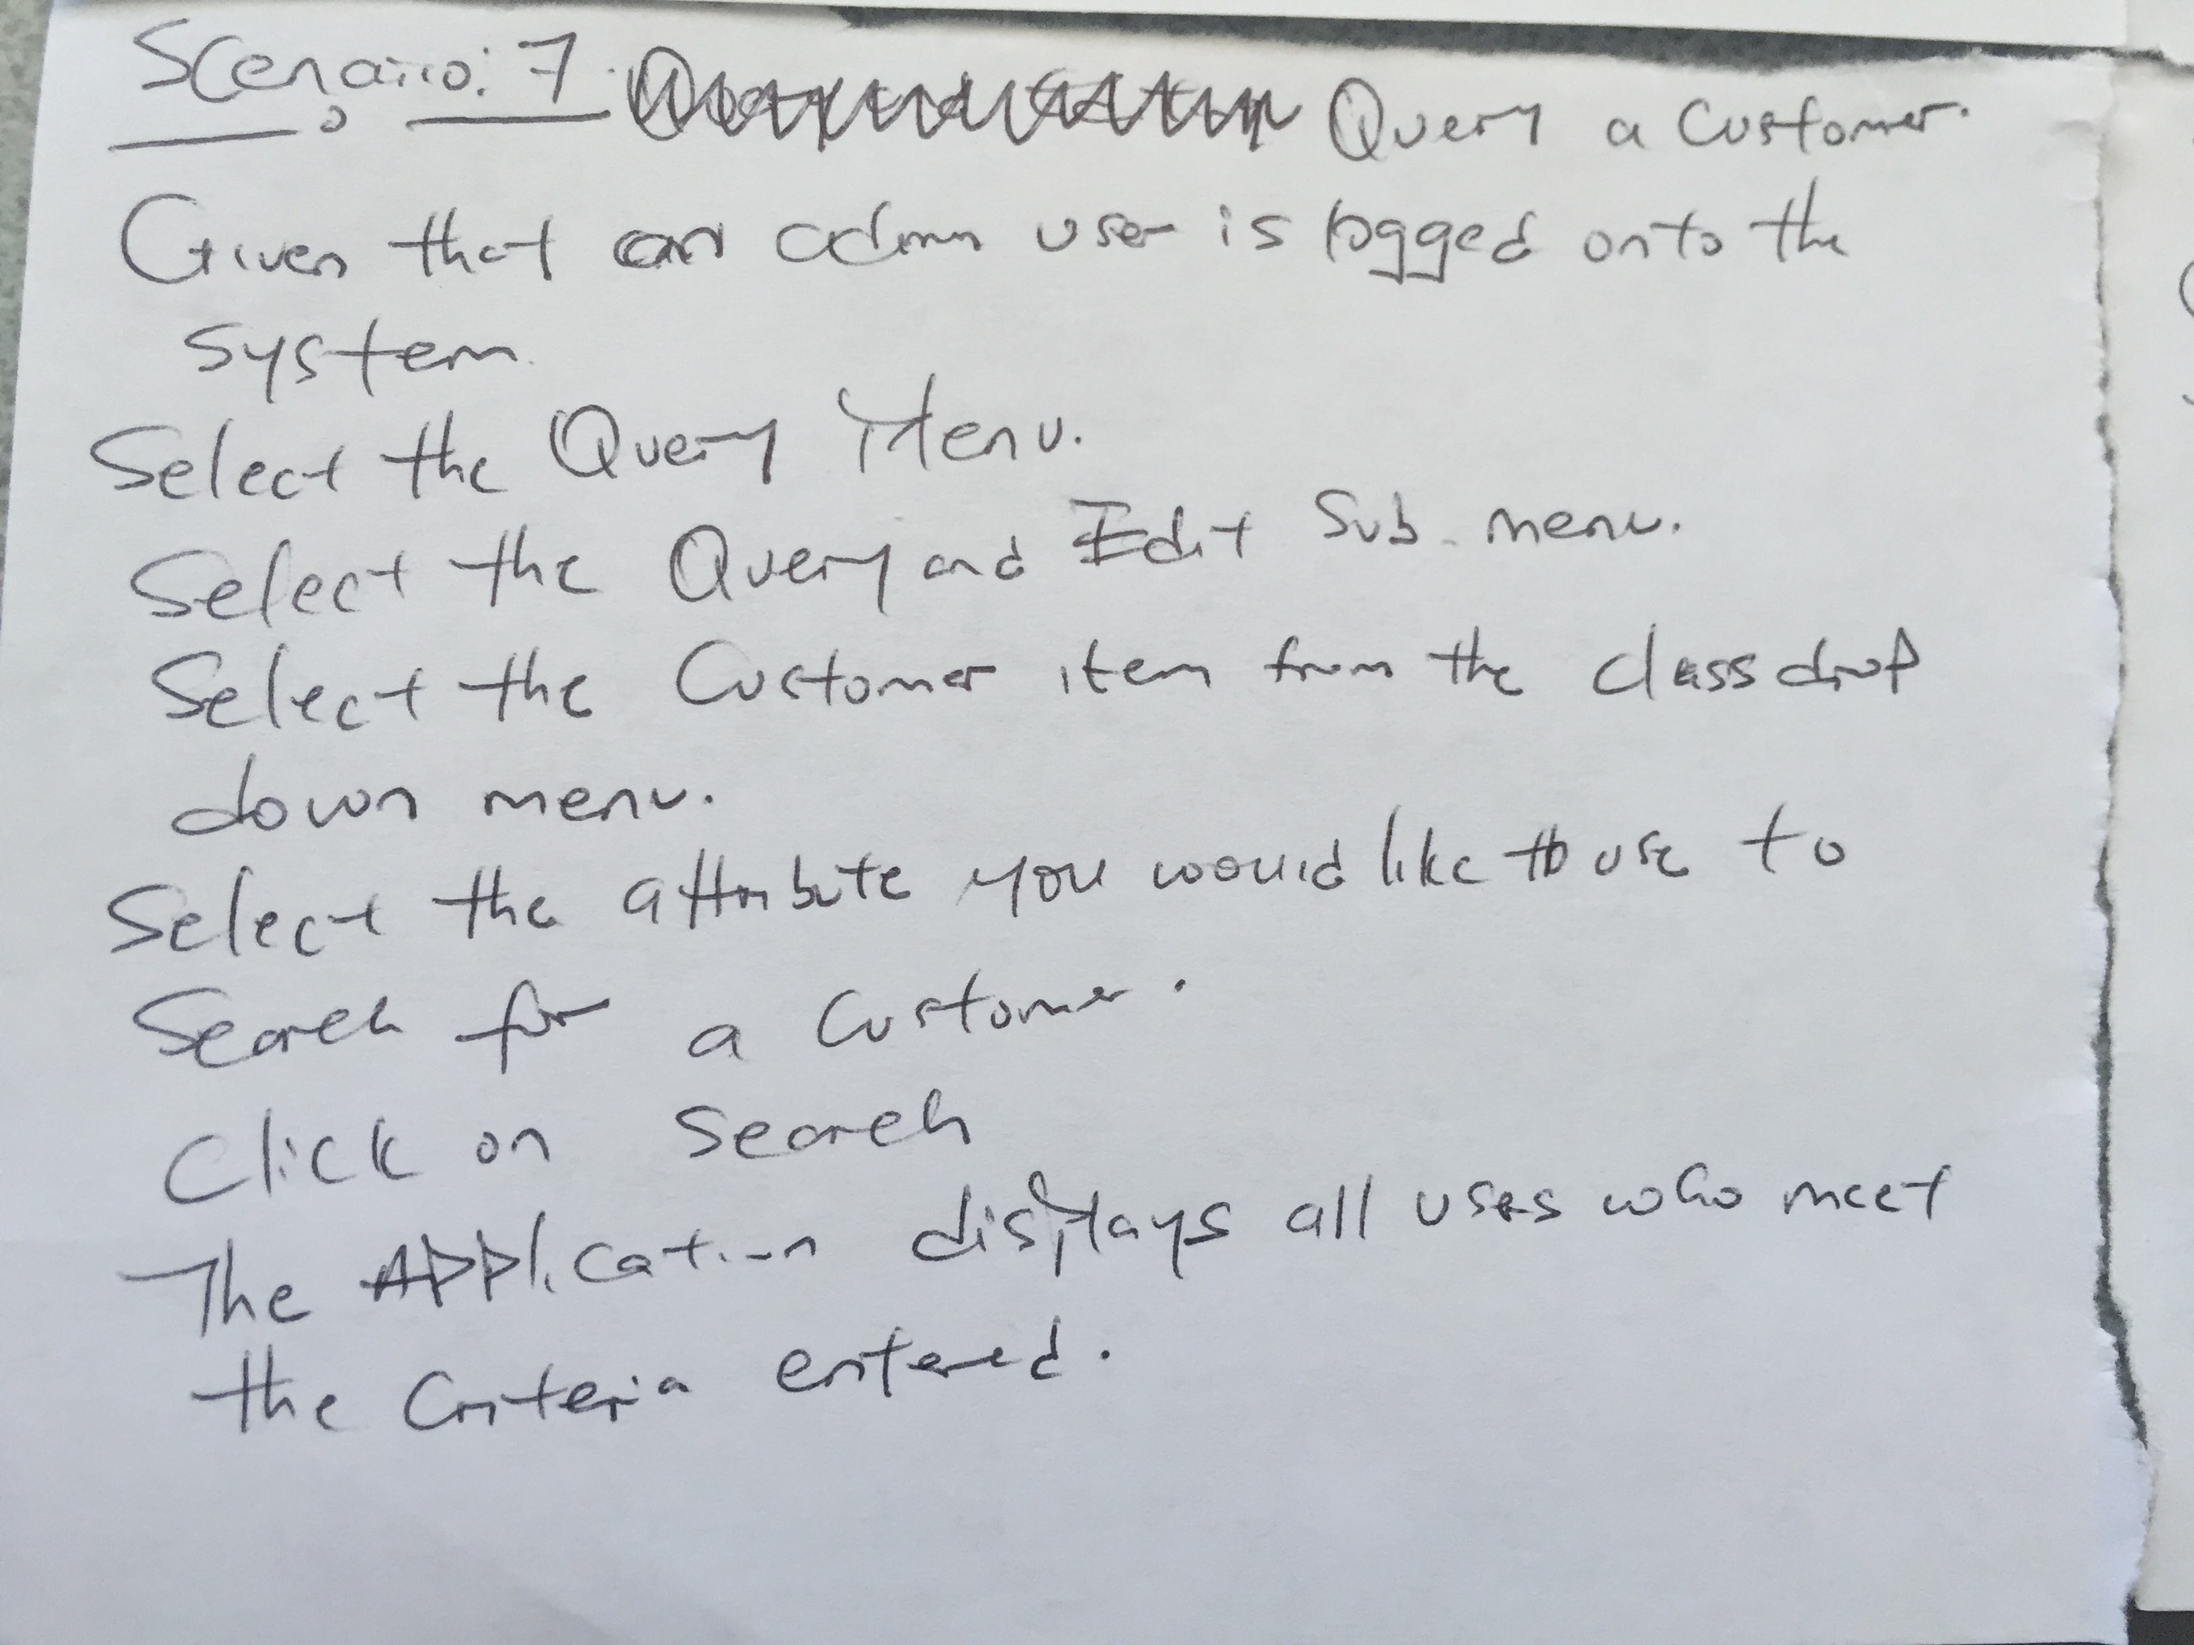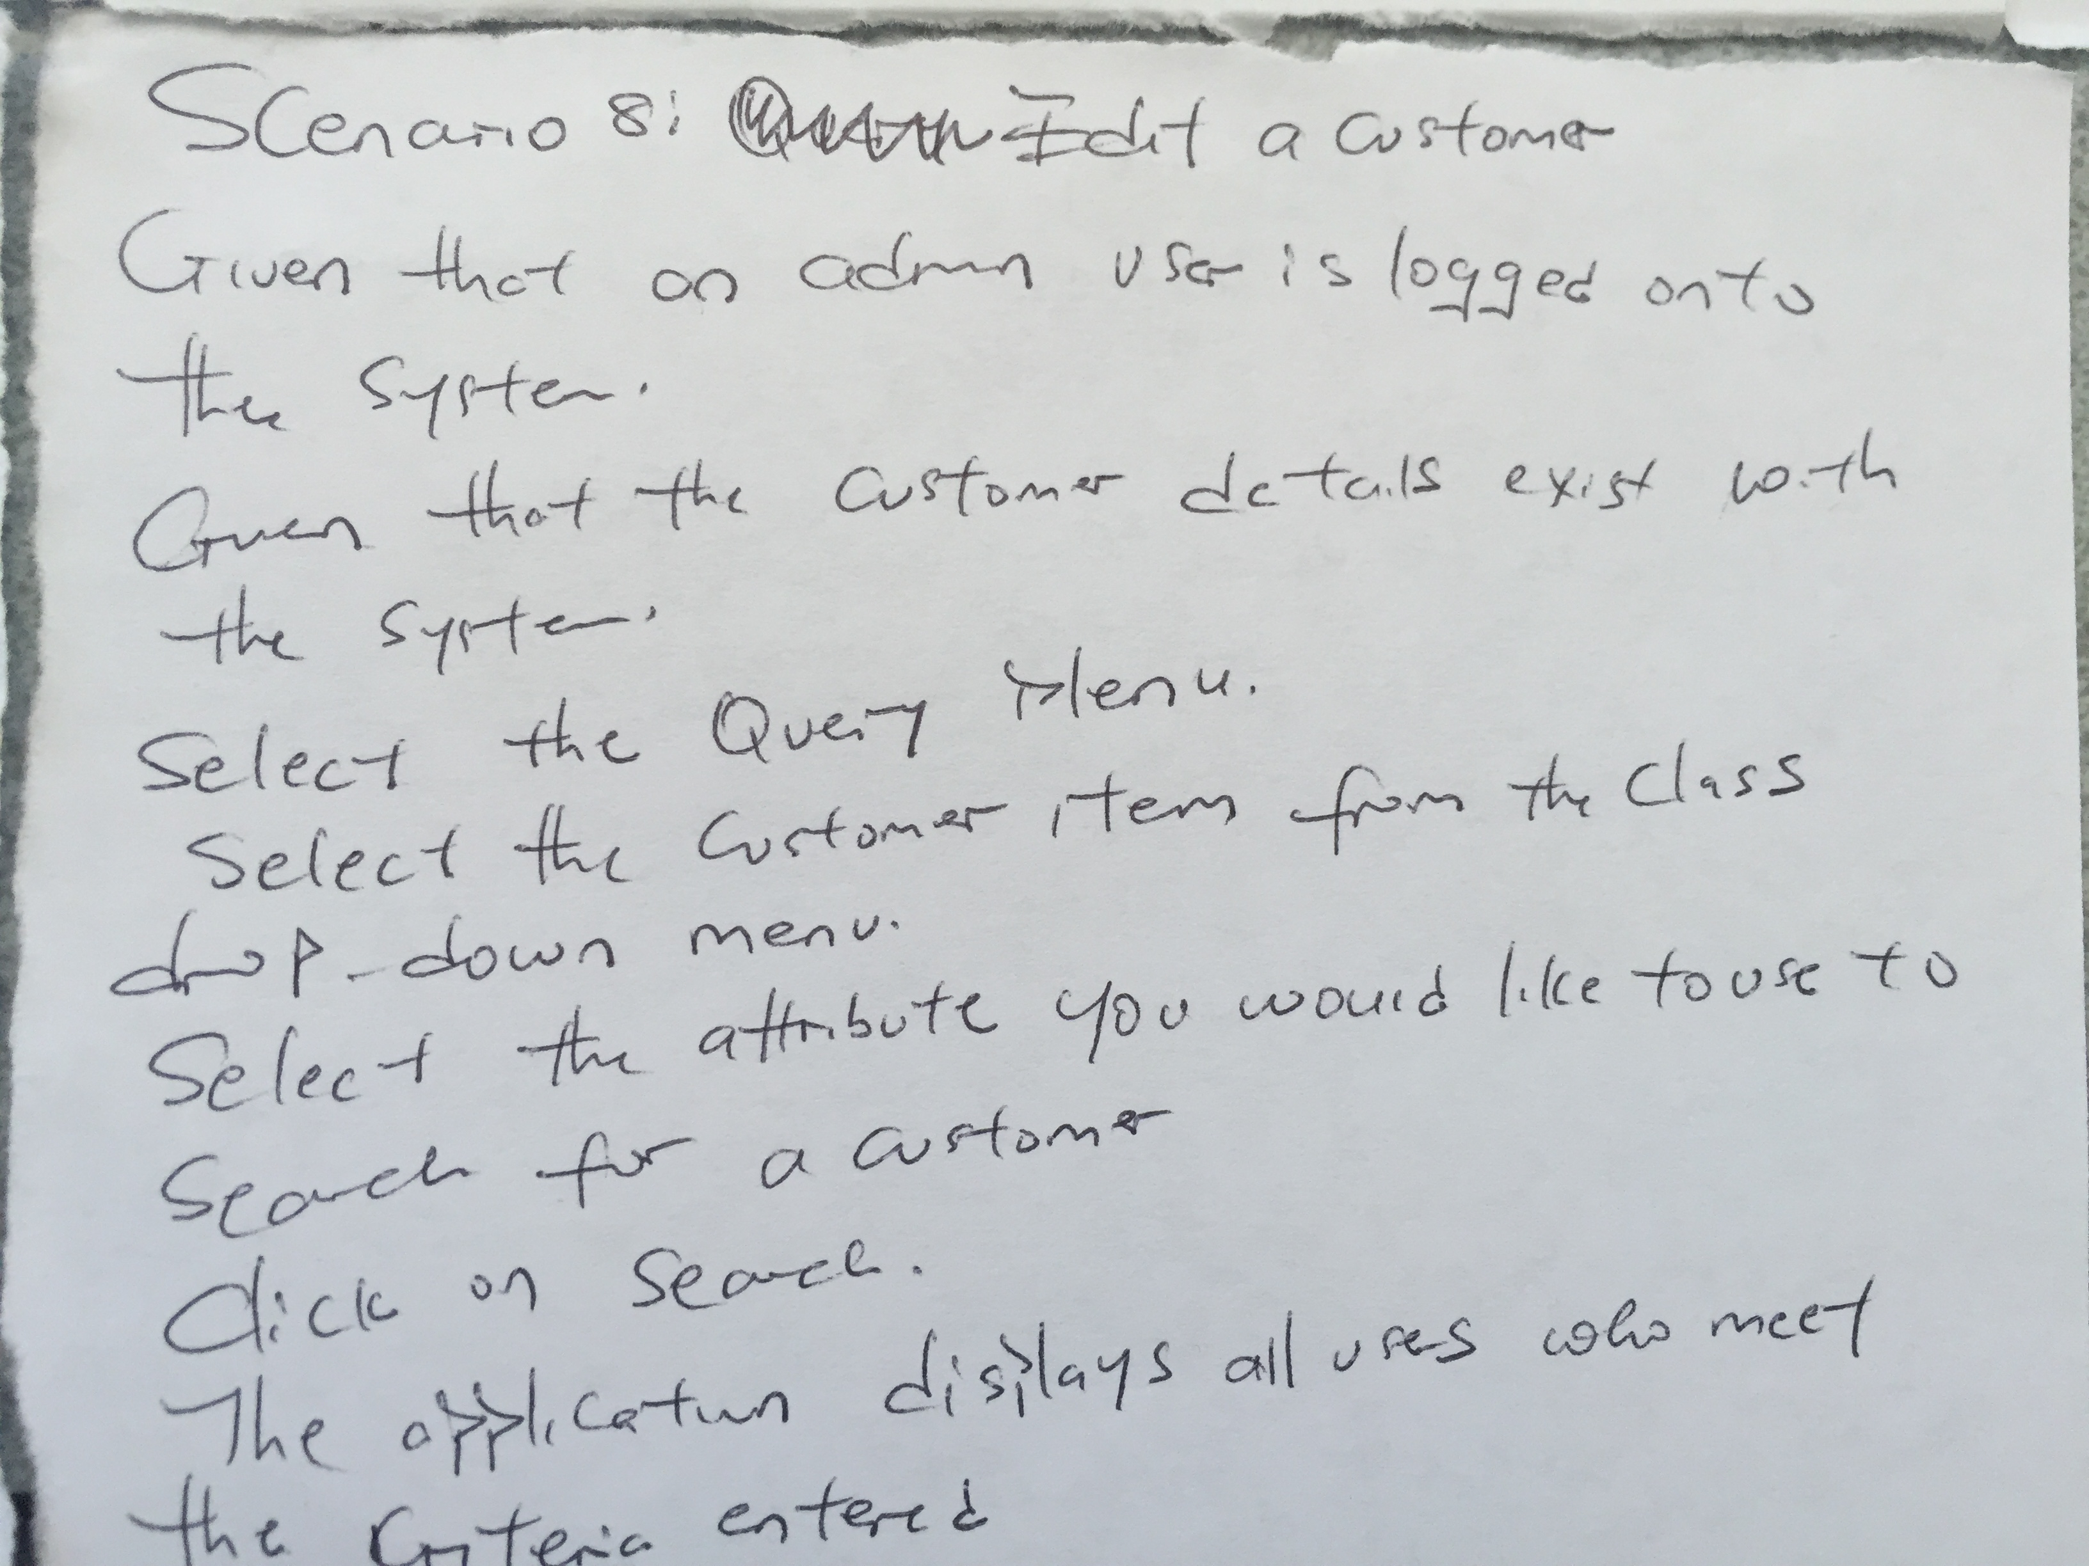

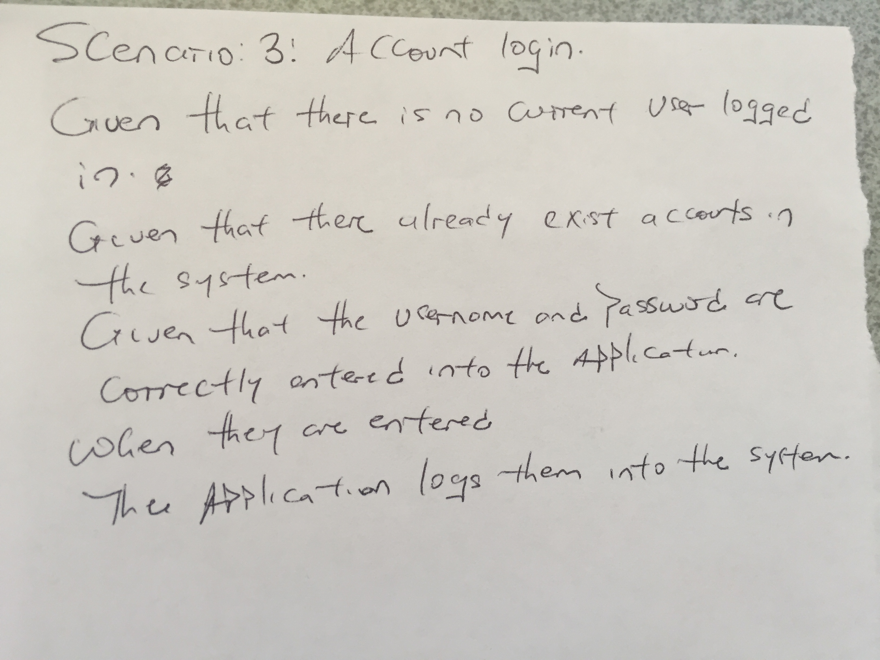

2.2 Activity Diagram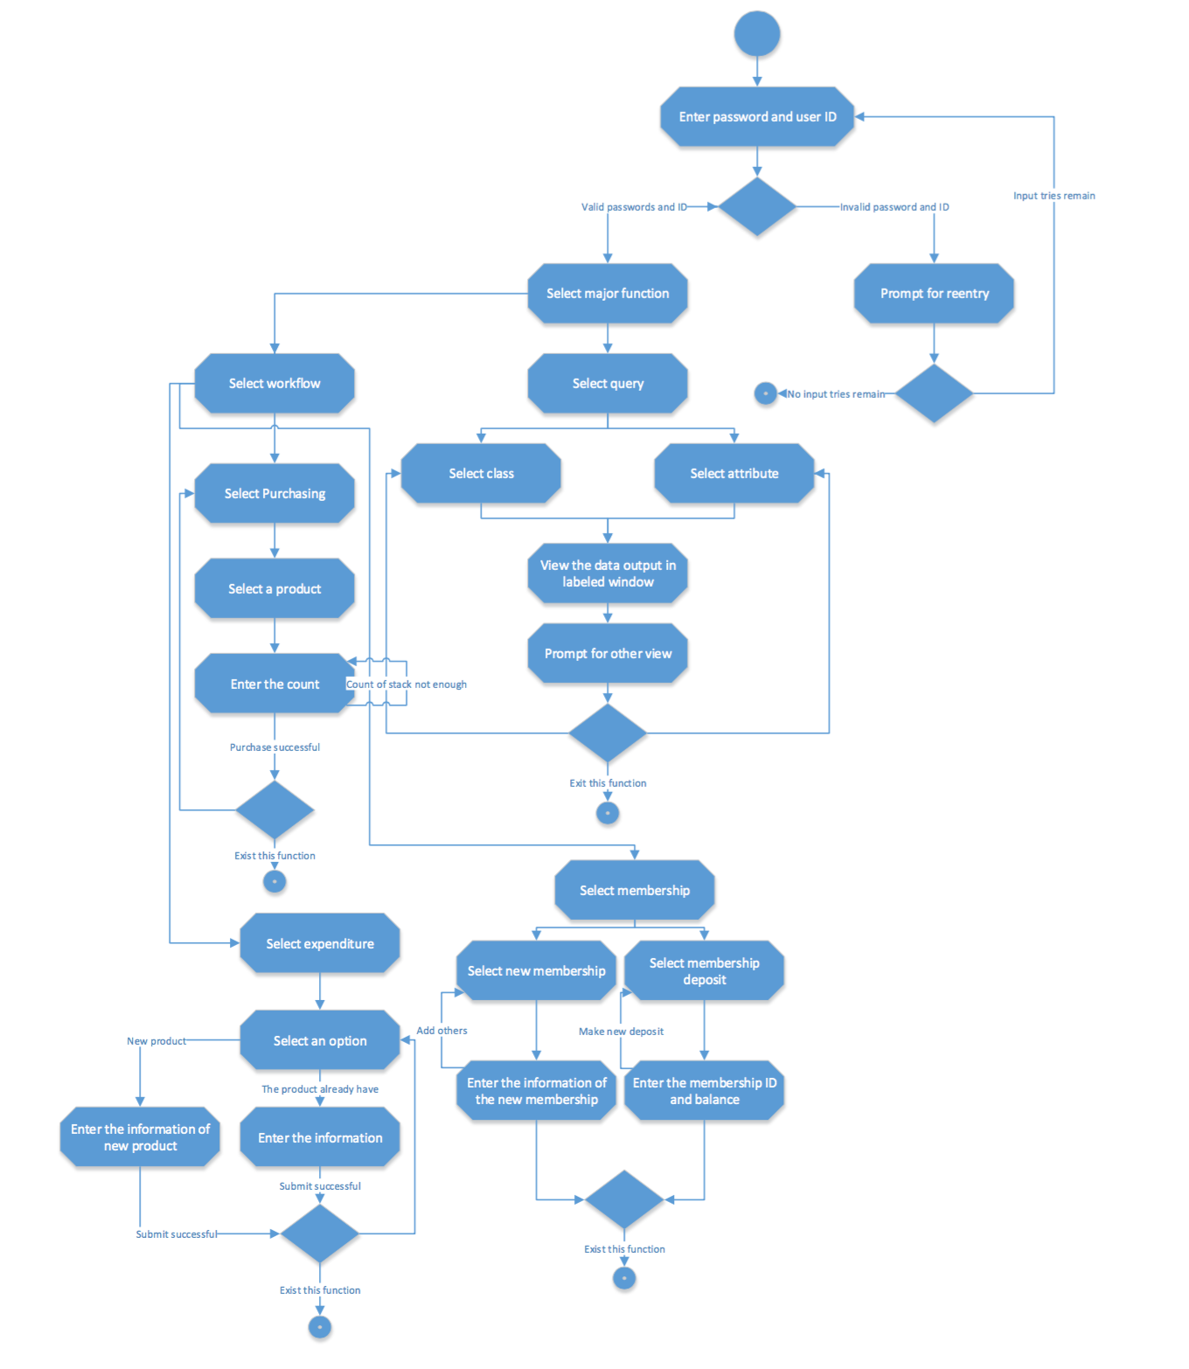

2.3 Swimlane Diagram

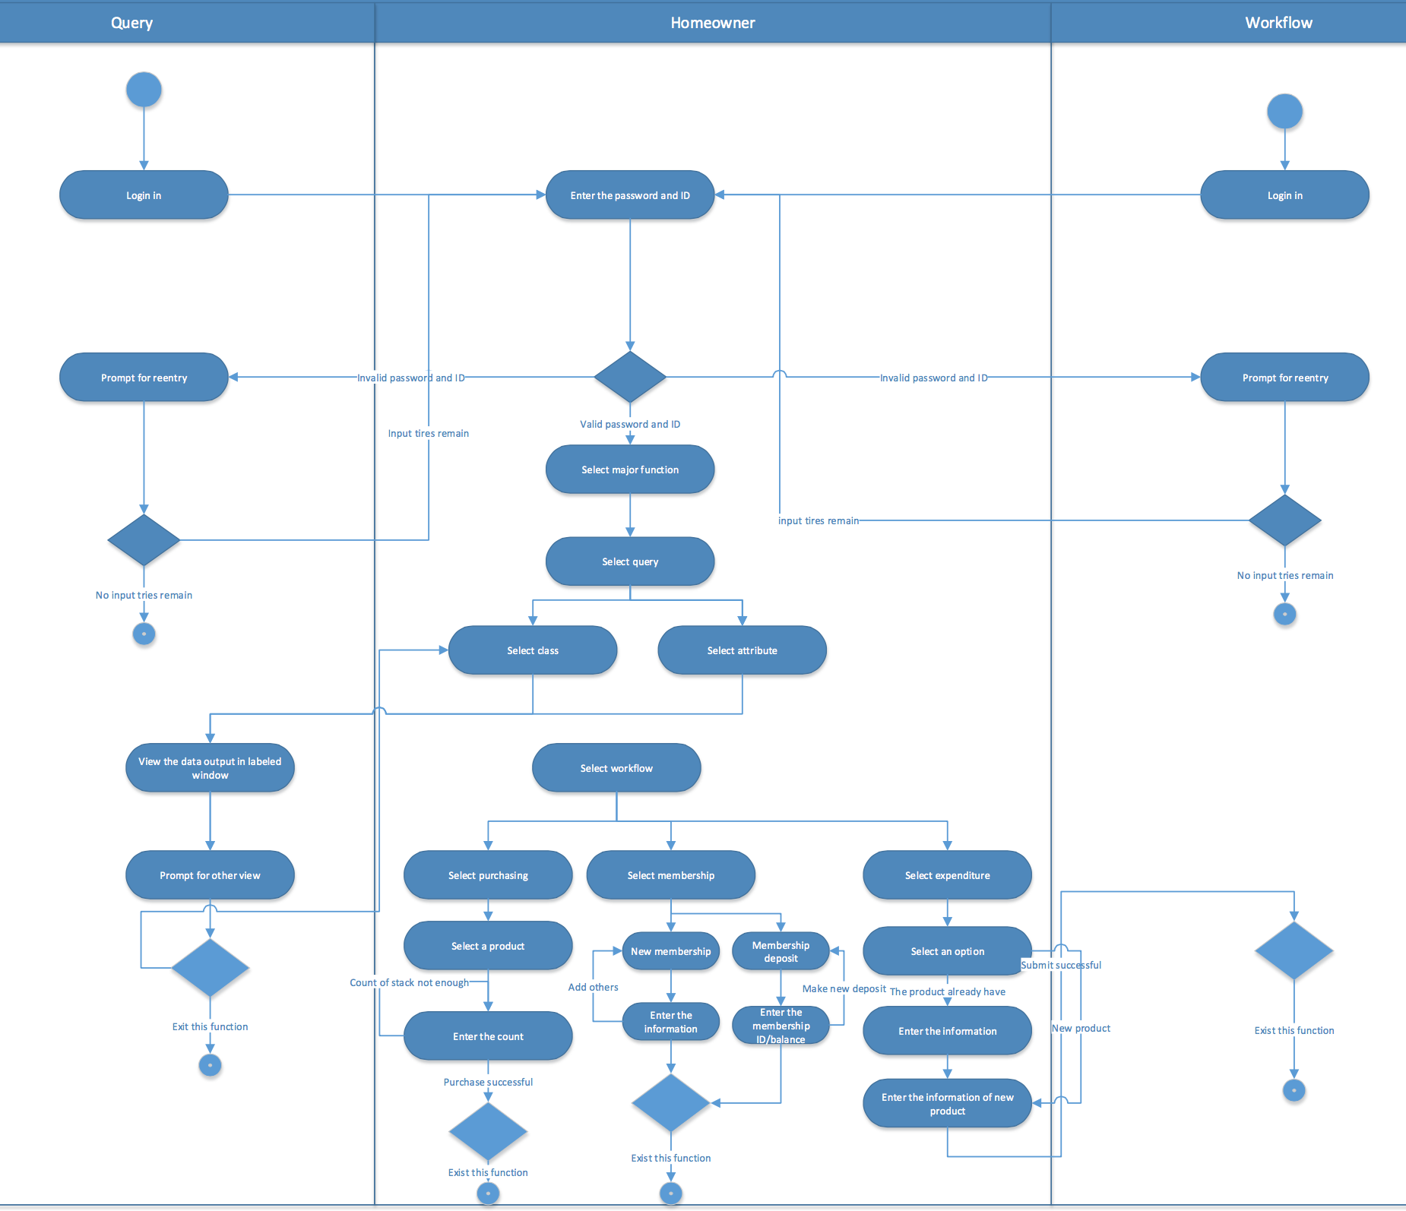

# Working Code

3.1 Data Model Sample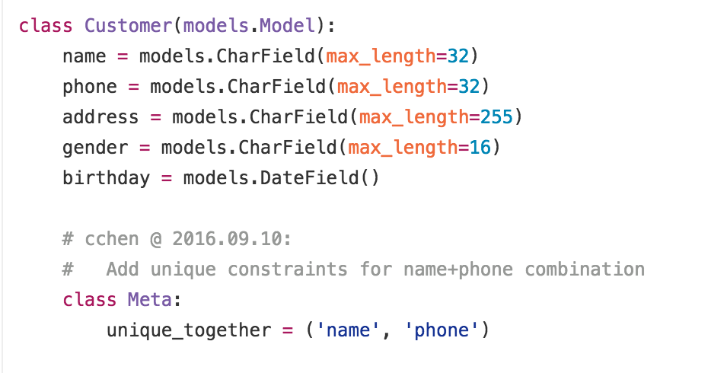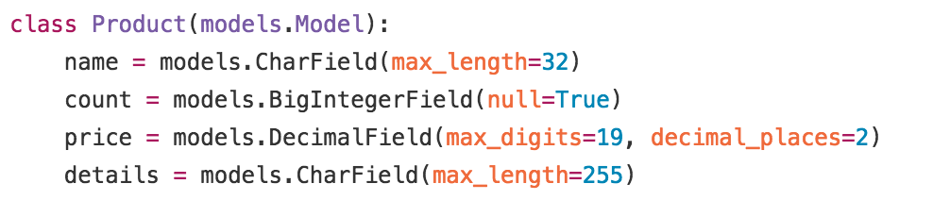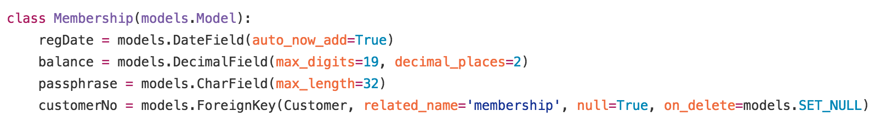

3.2 Interface

Below figure shows the overview of the web application’s framework, it also demonstrate how the web view handler interact with the user view an data models.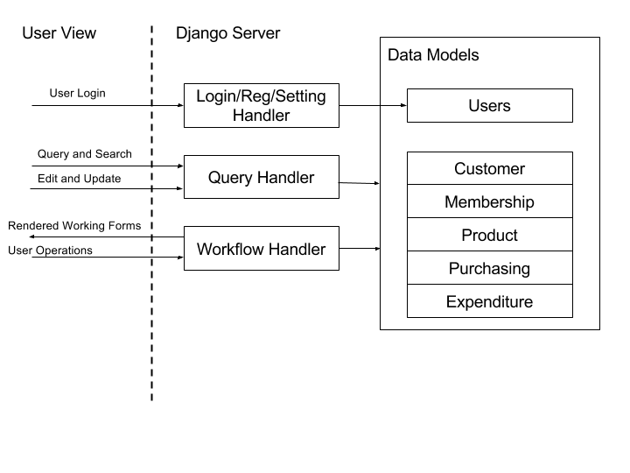

3.3 Code Sample

Below code section demonstrate how to perform user operations on data model, in this case, it’s creating or modifying product entry: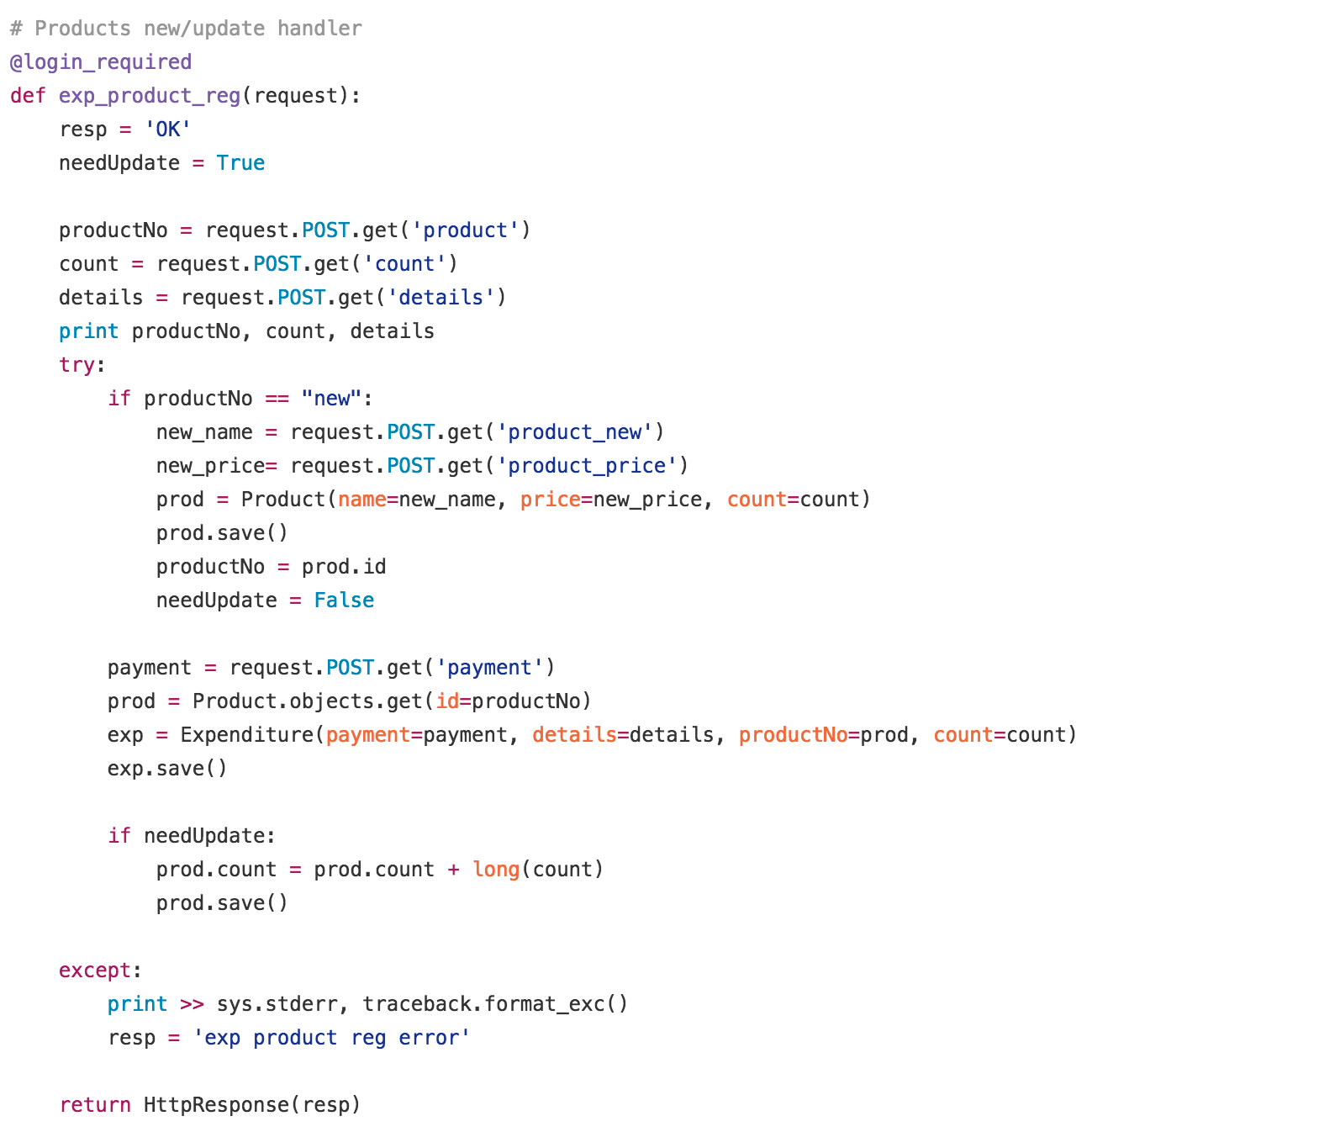

3.4 User Interface Screen

This project finally delivered a website that could be deployed on web server or local computer. Below screenshots show some user interface of this application:

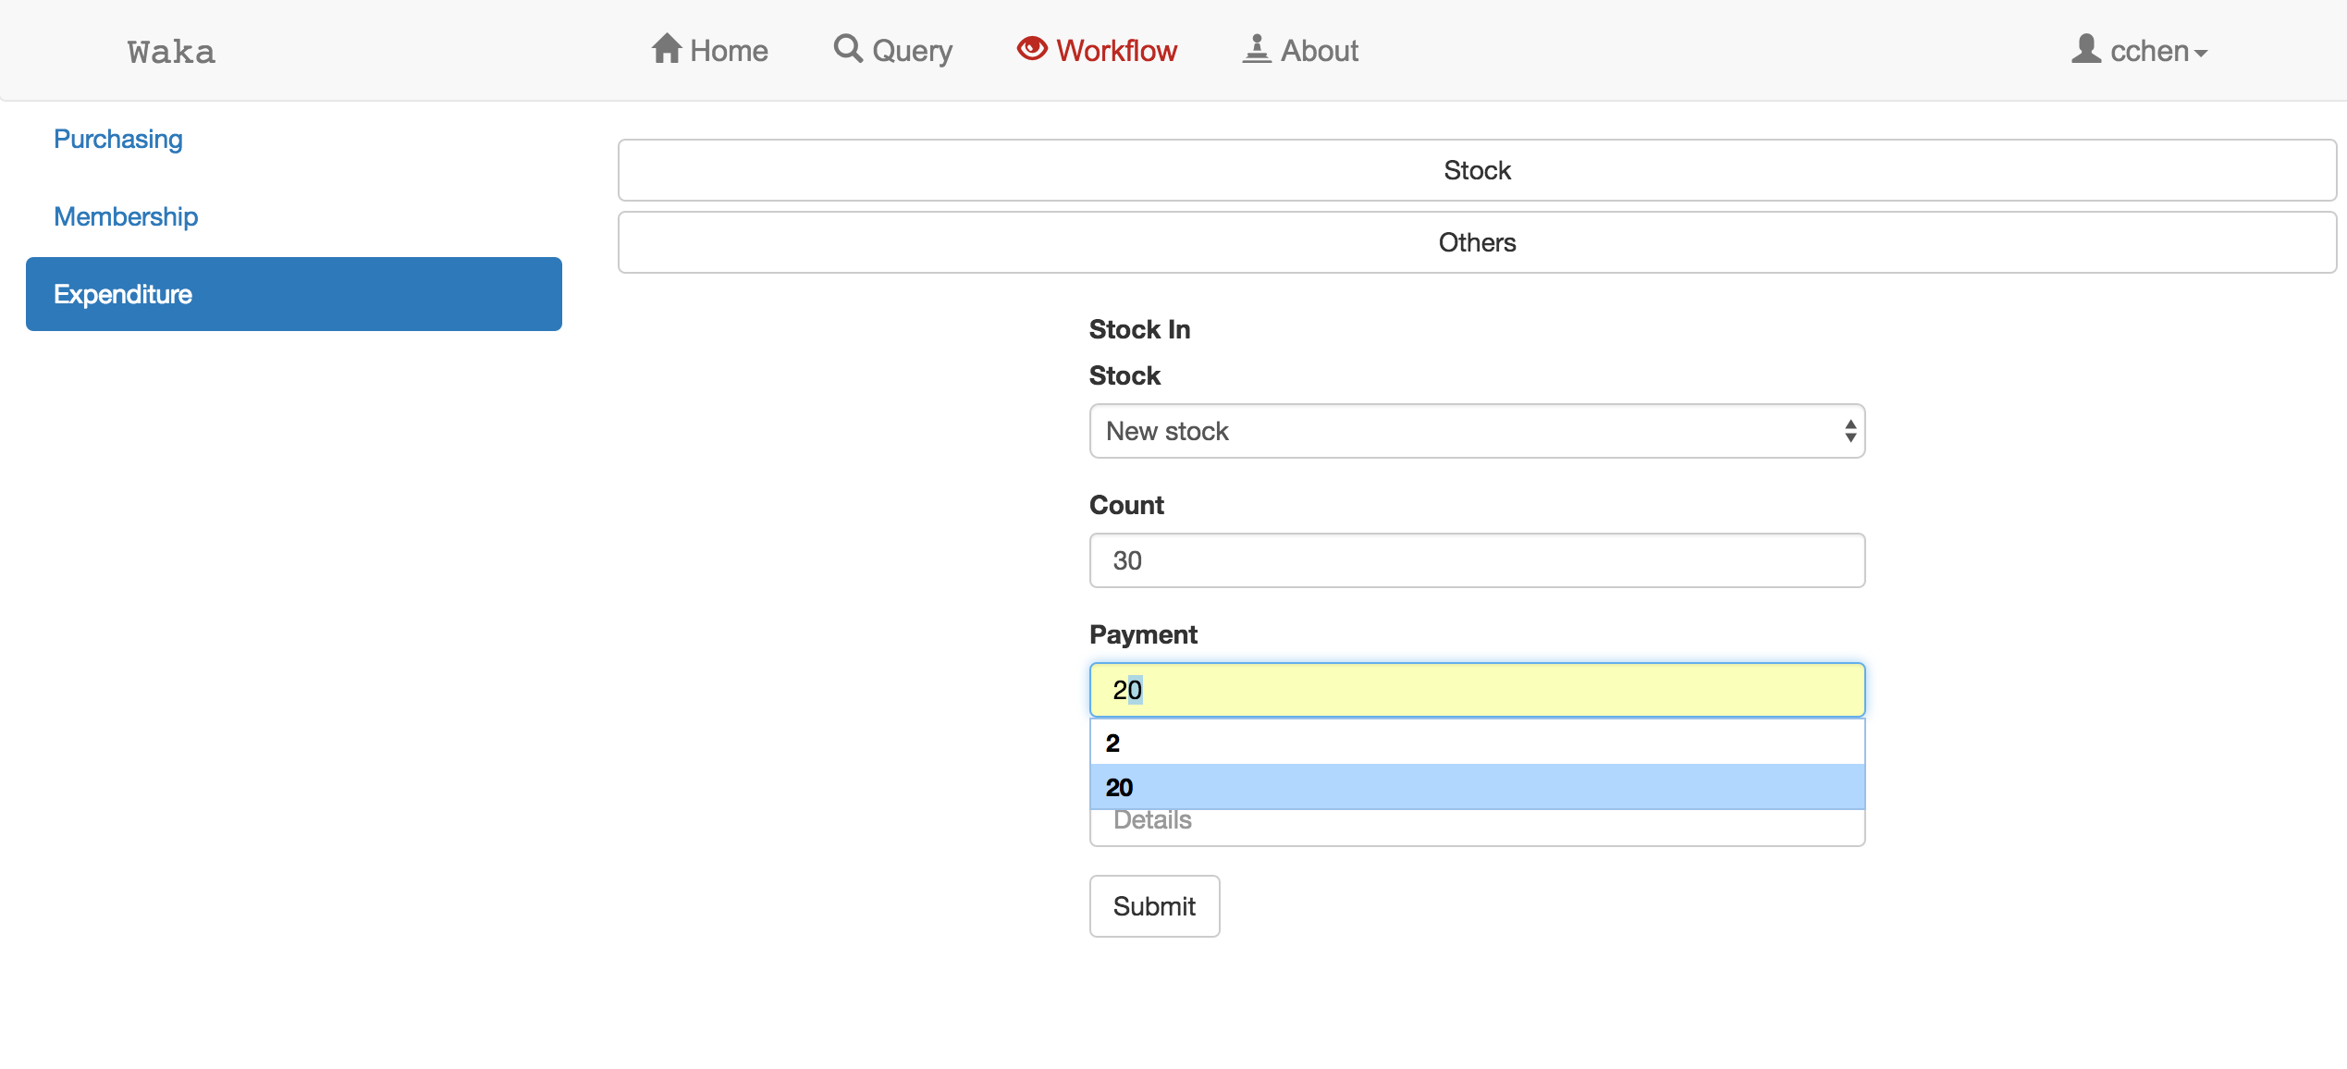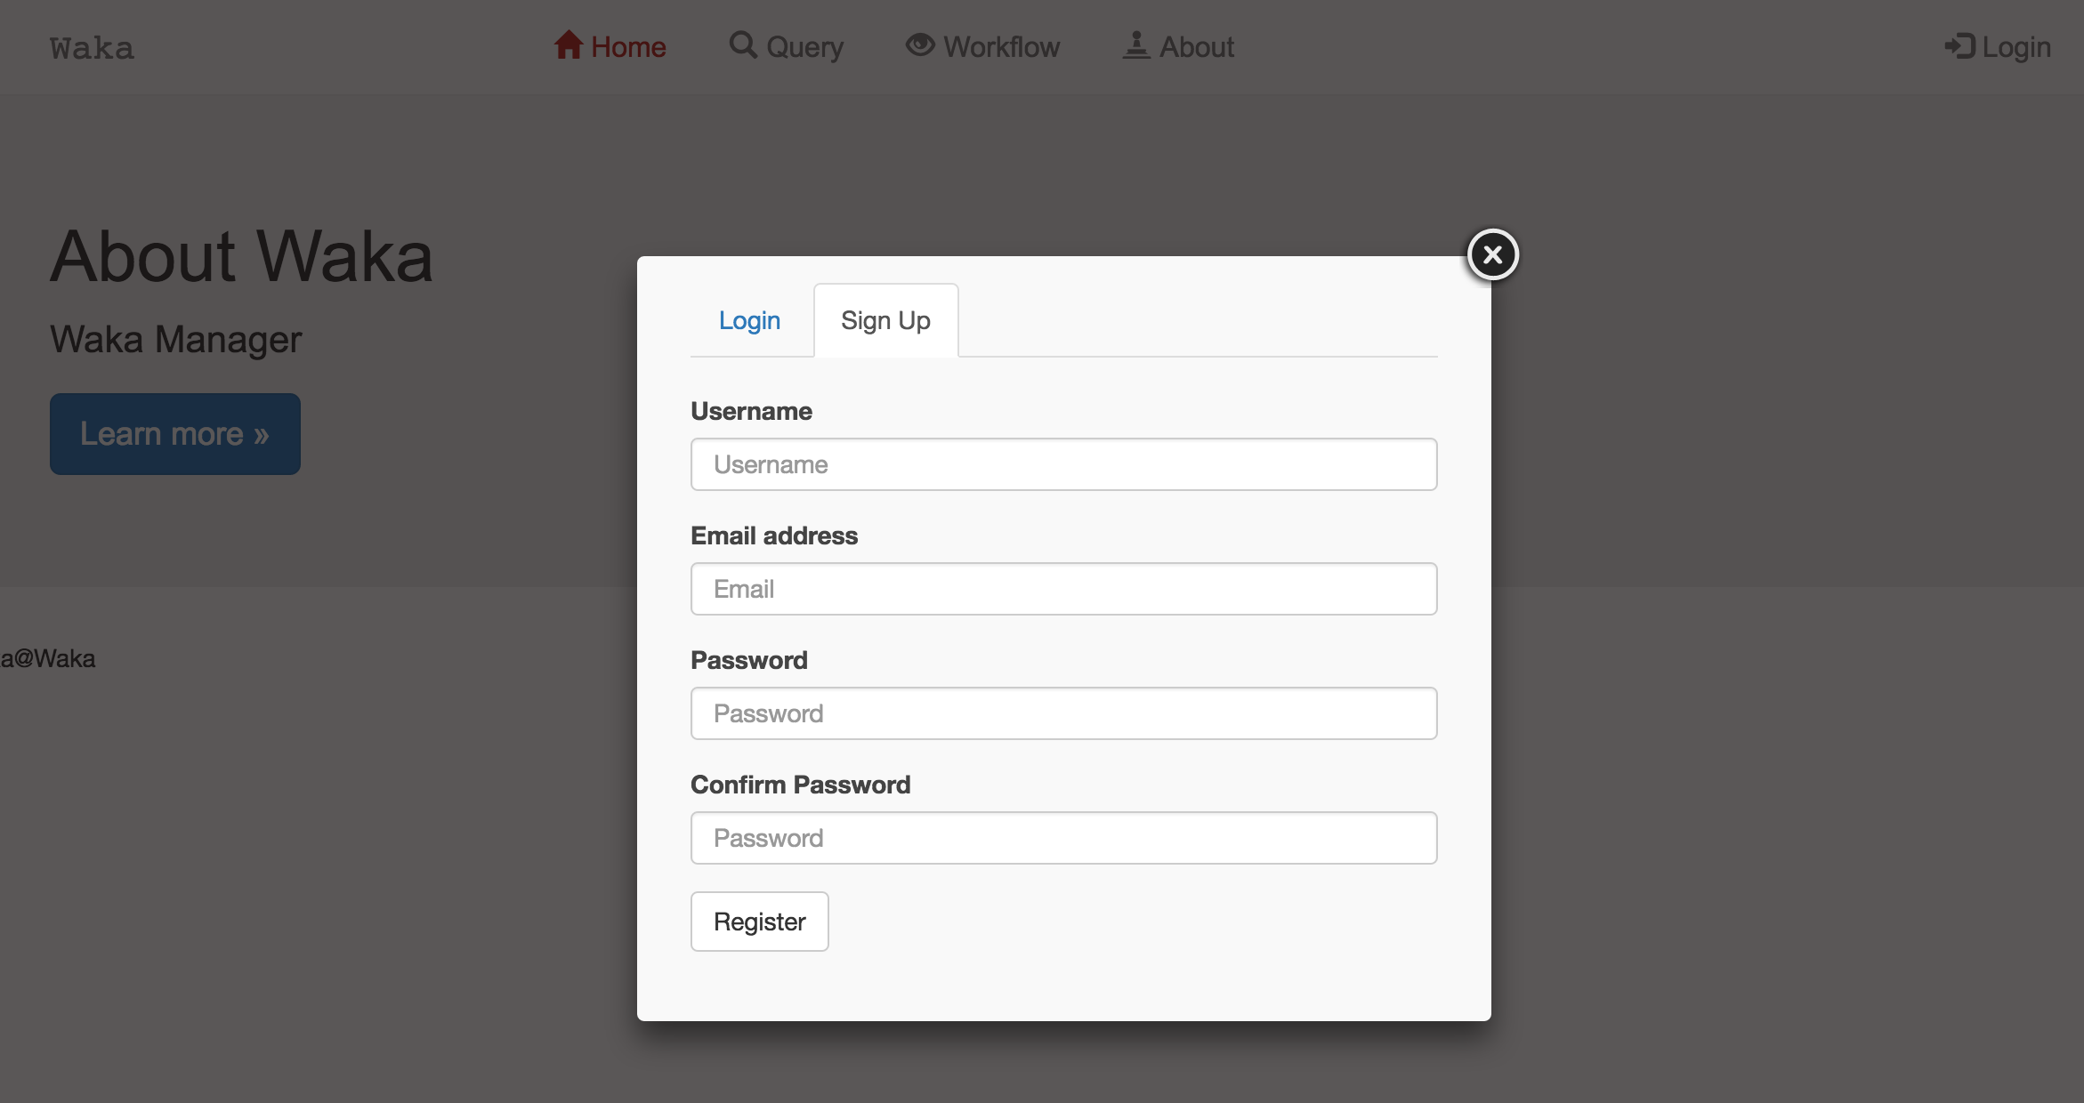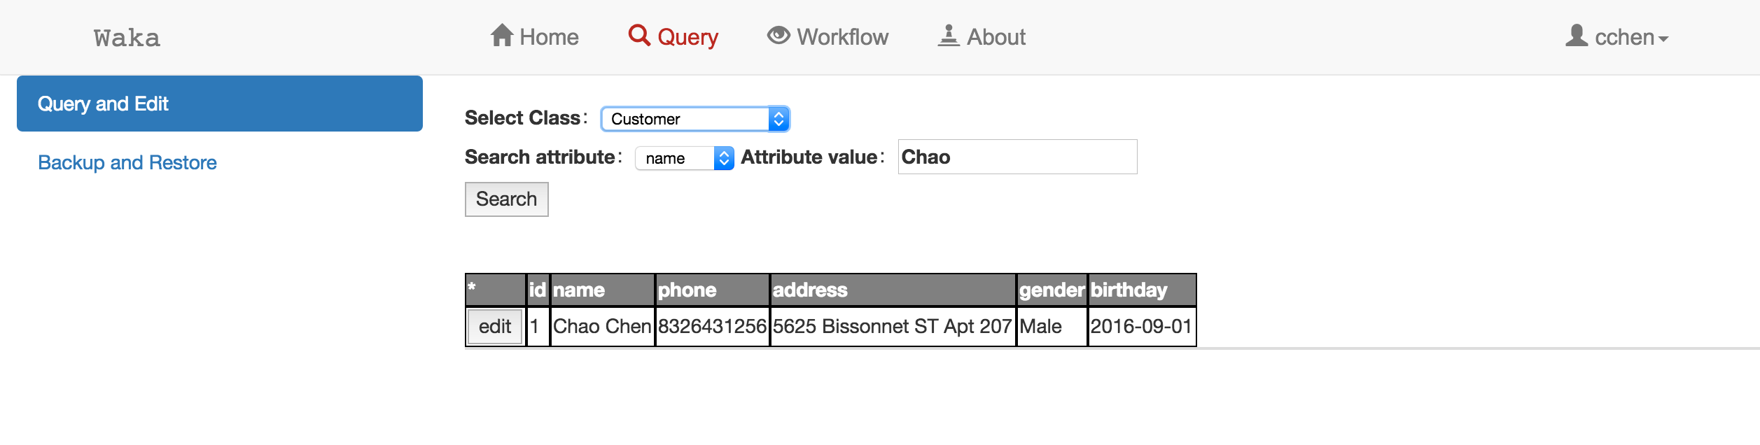

# Project Repository and Tools

4.1 Repository

This project uses GitHub as the source code control tool. Below figure shows the screenshot of the source code repository: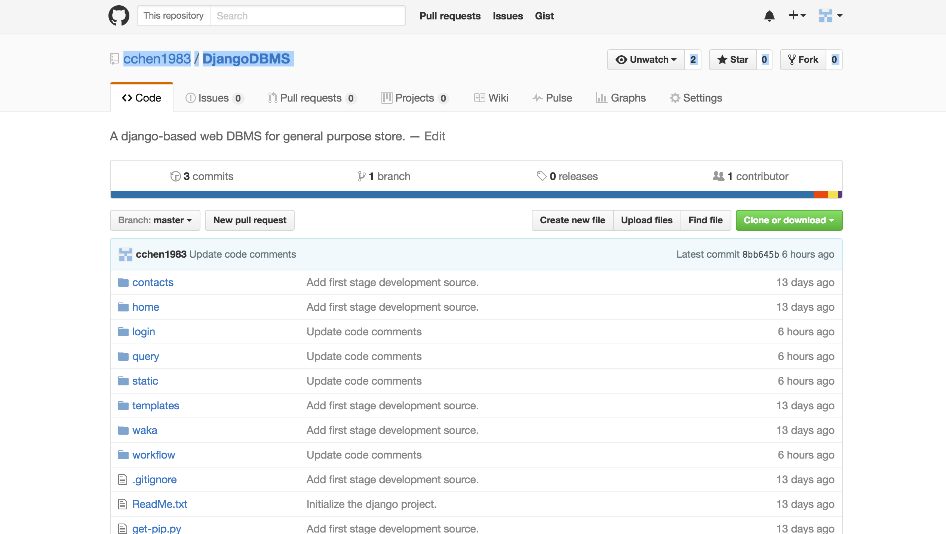

4.2 SCRUM Tool

For project management purpose, we use Scrumwise, an online SCRUM platform , to manage all the tasks and resources by evenly distributed them to multiple sprints. Below screenshot shows the situation in one of the sprints: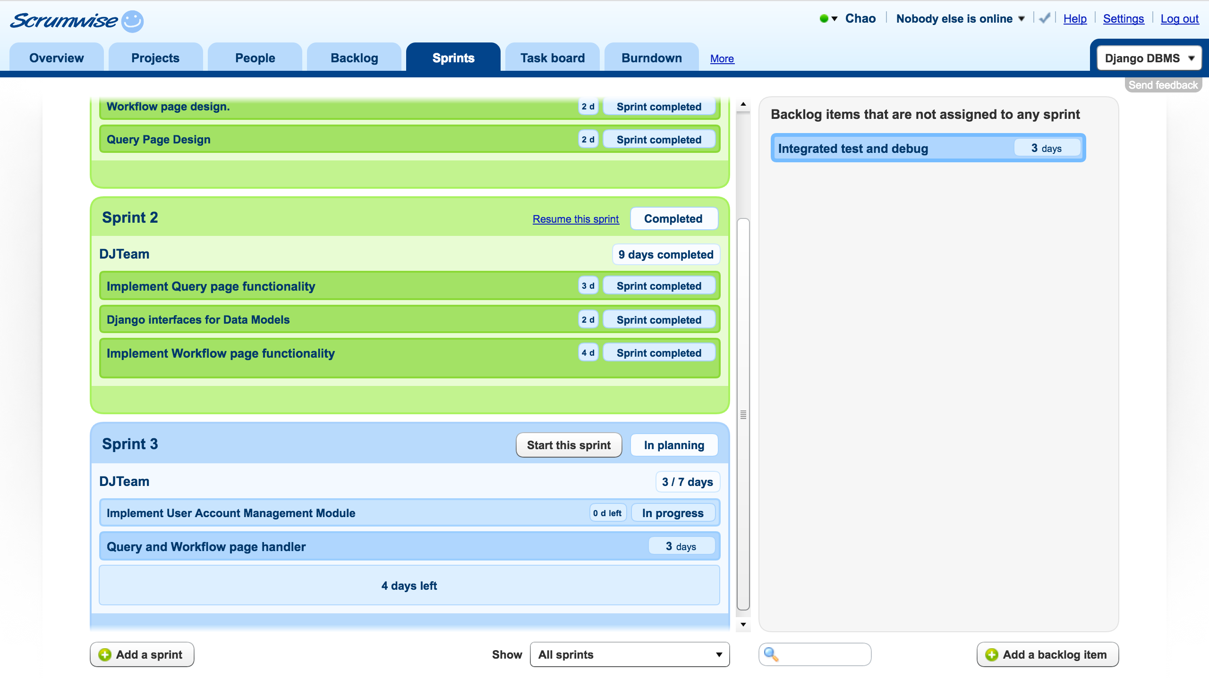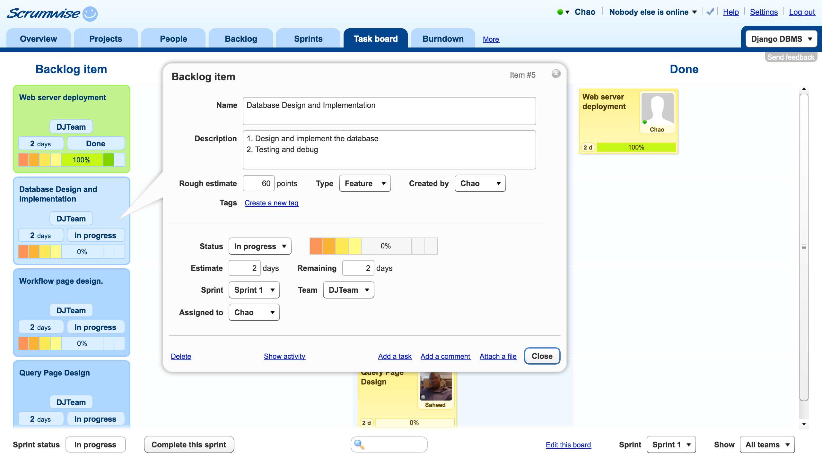

# Weekly SCRUM Sheets

# 